
The Weekly Bulletin of the Rotary Club of Kathmandu Mid-Town - Volume No. 18/01 for # 795 July 24, 2005
Editor: CSD Rtn. Walter Diller Layout: Rtn. Navyo Eller Web: www.rotarymidtown.org.np BC-email: diller@htp.com.np
THE BREAKFAST CHATTER

MIDTOWNERS SUNSHINE OF THE WEEK ► JULY 22-19 2005
SUNSHINE ANNOUNCEMENT FOR THE WEEK OF 22 July, 2005: NPR 1400
NO SUSHINE ANNOUNCEMENTS FOR THIS WEEK

SPEAKER OF THE WEEK ► RAM Binod Bhattarai THIS FRIDAY JULY, 29
THEME | THE BUDGET AND ITS IMPLICATIONS
Former secretary of finance and director of ADB, Manila will speak on chances and problems of the latest government budget

UPCOMING SPEAKERS ► PREVIEW
DATE | SPEAKER | THEME
05 AUG | In House Speaker PP Gopal | Impressions from Chicago Convention
14 AUG | 2 or 3 clubs meet in Grand Hotel at 8am | Rotary fellowship
14 AUG | Bibhuti Man Shrestha | Disaster management
12 AUG | Dr Hedamba Rajbandari  Chairman ND group and former secretary of Agriculture | Agro processing, a winners game?

THE LAST SPEAKER OF MEETING # 793 ► MRS INGE BRAAKE
Last Friday our speaker was Mrs. Inge Braake director of Shangri La Home
Born 1958 she went to School in Belgium, Her father a real estate broker was an old fashioned man who believed that girls don't need much education. So she left the school at an early age. While her two sisters became house-wives, she made the experience that education is very important, took up again school and became nurse with 27.

Interestingly her brother got a good education all due to the attitude of her old man.
For a few years she worked in Belgium in a hospital and then she came as a tourist to Nepal in 1991. She fell in love with this country and stayed here. After some trials, one of them a guesthouse in Thamel, she found her real destination. As she developed parallel to the activities in the guesthouse a children's house, which was in the beginning only for street children.
Sometimes it is good to make a detour because a friend from Belgium who stayed in her guest house encouraged her to develop these street children further and to create a home for them in which they could develop as useful members of the society.

With the help of her friends in Belgium which collected for each individual small money which became in the context of Nepal a reasonable amount she developed a house for them and nowadays over 118 children are living there. Starting from small kids to students of science. (her pride)
In the meantime she also developed places for drug addicts and for other youths which are living at the limit of society. While she has little interest to get support from government sources or INGO she depends fully on friends which are ready to give.

While she succeeded in one of her houses (she administers now three) to give the boys and girls working possibilities by producing ceramics and with this covering their main expenses, she is still trying to find a way to earn for the others. So she is actually trying to find someone to help her girls not to learn stitching only but eventual to produce some fashionable clothes as well. (I promised to help her to get a designer teacher, if that really helps the girls to earn something.)
It’s great to meet people who are focused on developing self help.

THE MIDTOWN CLUB ► NEWS
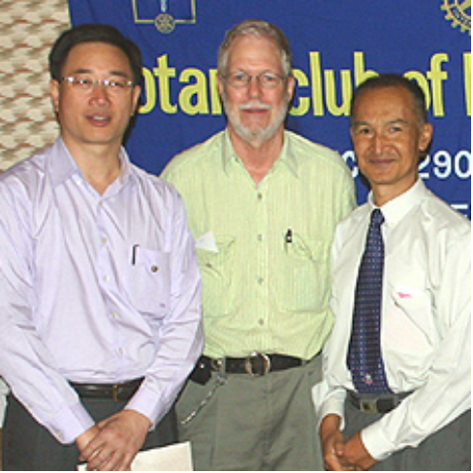 | Old Midtowner’s don’t forget us  Last Friday we all had the pleasure to meet our long time member Prof. Robert Scott.  Robert was in Nepal also to share the success of the research he does on Hepatitis Type E Vaccine testing.  For many years active member, his visit to our Club was one of the highlights and delights of the meeting.  We wish “Scottie” will visit us again soon, as he promised to come back time to time to Nepal, which he misses anyway.  Hearty greetings to Robert and spouse Giannina from the BC!

THE HEALTHY LAUGHTER CORNER

The importance of the internet
A little boy asks his father – Daddy, how was I born?
His Dad responds, “Ah my son, I guess one day you will need to find out anyway! Well, you see, your Mom and I first got together in a chat room on MSN. Then I set up a date via e-mail with your Mom and we met at a cyber-cafe.

We sneaked into a secluded room, where your mother agreed to a download from my hard drive. As soon as I was ready to upload, we discovered that neither one of us had used a firewall, and since it was too late to hit the delete button, nine months later a blessed little Popup appeared and said:
You've got male!

Who has another one? Come on Friday morning and share your ideas.

This Friday we will have another interesting speaker. Ram Binod Battarai has always been an interesting speaker in the past even though he is a bit serious kind of guy.

To all of you: help us to keep this BC and our Club a vibrant one! Send your information’s on eventually Rotary activity you know or you attend or which are going to be happen! Send us pictures of Rotary activities you attended.

Navyo is helping with the lay out. Who else is ready to contribute eventually articles?
Interesting articles are heartily welcome.

A WORD ON ROTARY ► SOME CITATIONS

Rotary looks at literacy
Close to a billion people lack the most basic literacy skills with millions more functionally illiterate, lacking the tools to meet the demands of everyday life.
Every July, Rotary clubs across the world focus on ways to address these problems through literacy initiatives.
This year, RI President Carl-Wilhelm Stenhammar continues Rotary's emphasis on literacy — and the key role Rotary clubs can play in helping promote literacy throughout the world
In addition to President Stenhammar's personal initiatives, Rotary International offers a number of resources to help Rotary clubs plan and implement local and international literacy projects.

Africa’s first international project fair
West African RI District 9100 is hosting the continent's first international projects fair in Accra, Ghana, 13-15 October 2005. Modeled on the hugely successful Uniendo América, an annual Central American projects fair, the forthcoming event targets participants from all over Africa, Europe, and the United States.
Organizers bill the fair as an opportunity to establish club-to-club relationships, make a firsthand assessment of the development needs of West African communities, and enjoy the hospitality and tourist destinations of Ghana and the surrounding region.
Clubs and districts offering initiatives that address community development, health and nutrition, literacy, and water and sanitation, as well as projects specifically aimed at improving the lives of the disabled, are especially welcome.
"We are hoping that it is a very successful fair so that clubs and districts in other African regions can benefit from our experience," says Robert F. Atta, a past governor of District 9100 and chair of the organizing committee.
The organizing committee has also invited Nigeria's four districts to be co host’s, and U.S. District 5170, through Past District Governor Brad Howard, is playing a supportive role of fair promoter in the United States.
In addition, District 9200, which comprises Rotary clubs in five eastern African countries, will be officially represented at the fair.

THE LAST CORNER ► BY CLUB SECRETARY R.R. SHRESTHA

Double click on the image to enjoy the PPP

SEE YOU ALL COMING FRIDAY ► YOURS IN ROTARY - CSD RTN. WALTER DILLER
THE BREAKFAST CHATTER
The Weekly Bulletin of the Rotary Club of Kathmandu Mid-Town
Editor: CSD Rtn. Walter Diller Layout: Rtn. Navyo Eller
Web: www.rotarymidtown.org.np BC-email: diller@htp.com.np

